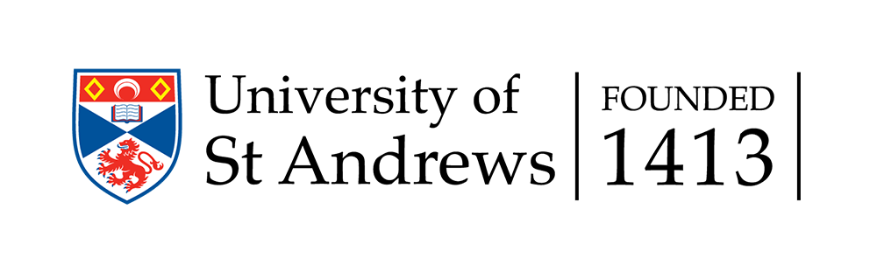

Logia Global Partners (LGP)
Application Form

Date: __________________________

Organisation/Institution:___________________________________________________

(This form is a printable version of the instructions stated online. We need elaboration from your organisation regarding answers to the three criteria stated below. Those can be addressed by typing into this document or by sending a separate attachment to logiatheology@gmail.com)

Background
In 2017, Logia International was founded at the University of St Andrews, in the School of Divinity, within the Logos Institute of Analytic and Exegetical Theology. As part of the Logos Institute, we seek to further its aims (to bring together the disciplines of theology, analytic philosophy, and biblical studies) by specifically encouraging and developing women across these disciplines. Logia recognises that women face particular barriers to progression and remain underrepresented at senior levels in divinity departments in Higher Education and in the theological leadership within churches across the world. Logia programs and events are designed a) to highlight the excellence of women already active in leadership in the academy and the church; and b) to develop the excellence of women training for such roles.

Some countries now have comparable programs within their Higher Education sector and policy more widely (e.g. the Athena Swan award within the UK). Acknowledging the distinctive challenges that can occur for women within Divinity, Logia is designed to complement, and support divinity departments’ work with such programmes where they exist, and to enable (not increase) the work of Gender and Equality Officers within schools. This may look like resource sharing of gender climate assessment surveys, tools for addressing gendered barriers such as mentoring scheme design, informal consultancy, etc.

Logia Global Partners (LGP)
Logia International’s vision is not limited to St. Andrews but seeks to support women in divinity world-wide. Of especial concern for Logia is to highlight the excellence of women from ethnic minority groups. Thus, Logia is pleased to invite external organisations who share our aims to become Logia Global Partners (LGP). To become a Logia Global Partner, application must be approved by the Executive Director of Logia, in conjunction with the Logia Advisory Board. To be approved, an organisation or institution must, minimally, meet the following criteria:

- Most broadly, an LGP must actively promote Logia’s Vision in a way that fits the partner’s own distinctives and mission. This vision states: “Logia hopes to increase the visibility of women in the academy and the church so that women’s voices may be more valued in these contexts. Thus, supporting women pursuing postgraduate divinity education is a means to Logia’s primary end: to encourage women’s full participation in the academy and the church according to each woman’s convictions and conscience.”
- An LGP will actively seek to assess its own organisation’s gender climate. (In the case of institutions who have applied for a third-party certification regarding their efforts to improve their institutional gender climate, that data can be sent and does not need replication. For organisations or institutions who have not assessed their gender climate, gender climates assessment templates can be found on the Logia website).
- Based on this assessment, the LGP will craft an action plan including measurable outcomes to address the areas of growth needed in its own organisation. Logia’s vision statement links postgraduate divinity education and women’s participation in the church. We are committed to the idea that increasing women’s education helps equip them for roles in the academy and church according to their consciences.
An LGP may be in various stages of assessment and development of an action plan (criteria 2 and 3) at the time of submitting the application, but the meeting of these criteria must be in process at the time of the application submission. Progress reports may be requested by the Executive Director even if an initial LGP designation is approved.

What does it mean to be a Logia Global Partner?
Whilst programs, events, and activities will differ depending on each organisation’s own context and culture, broadly speaking and as described above Logia works at two different levels: a) highlighting, and b) developing excellence amongst women in divinity. As such, we hope that a Logia Global Partner will seek, as appropriate, to highlight the excellence of women faculty, staff and students; and, as appropriate, to develop the excellence of women faculty, staff and students at their organisation/institution. Some examples of ways to do this can be found on our website.

What will we do?
Highlighting:
Logia International can highlight and promote your scholars and events through our website and contacts, including, but not limited to, hosting web pages for global partners, spotlighting women doing work at your institution, listing names and links on our global database, and inviting contributions to our blog. This is a resource that will enable the construction of gender balanced syllabi, reading lists, conference programmes and research invitations around the world, as well as attract women of excellence to study or teach at your institution.

Developing:
Logia International can assist you to develop women’s excellence by:
- providing ideas for programmes and events
- encouraging students to be mentees in our global mentoring program
- providing publishing help to early-career scholars through our Prepare to Publish (P2P) program
- using Logia branding
- helping to establish links with publishers
- personally meeting wherever possible (usually at conferences)
- coordinating bi-annual Skype calls with the Logia Executive Director, for encouragement, strategy, consultation on gender climate and responses, etc.

What will you do?
Once an application is approved, a Logia Global Partner will provide a bi-annual activity report to the Executive Director, outlining activity and action taken toward progress on (2) and (3).

We look forward to this partnership as we help women both to see what they want to be and to believe that they can be what they see!

The Logia Advisory Board (LAB) consists of women and men with expertise in the divinity disciplines and publishing world. The responsibilities of the board members include consultation by the Executive Director of Logia within their area of expertise, being publicly listed as supportive of this organisation, and promoting Logia in their spheres of influence when possible. The Board receives a quarterly report from the Executive Director and serves on a two-year, voluntary basis. For an LPG to be approved by the LAB, there cannot be disagreement of more than one-third of the responding board members.
Examples of measurable outcomes in a higher education setting include (but are not limited to): the number of women studying in postgraduate programmes and on faculty; female/male representation on syllabi, in presentations, and in strategic leadership roles; the grade/publication rate of female scholars compared to male scholars, feedback from the women in your institution regarding the changes made after the action plan has been actioned, etc). In a church setting, examples include: women in preaching, teaching, and senior leadership roles; serving on committees, and women becoming ordinands or participating in ministry training schemes, etc.

